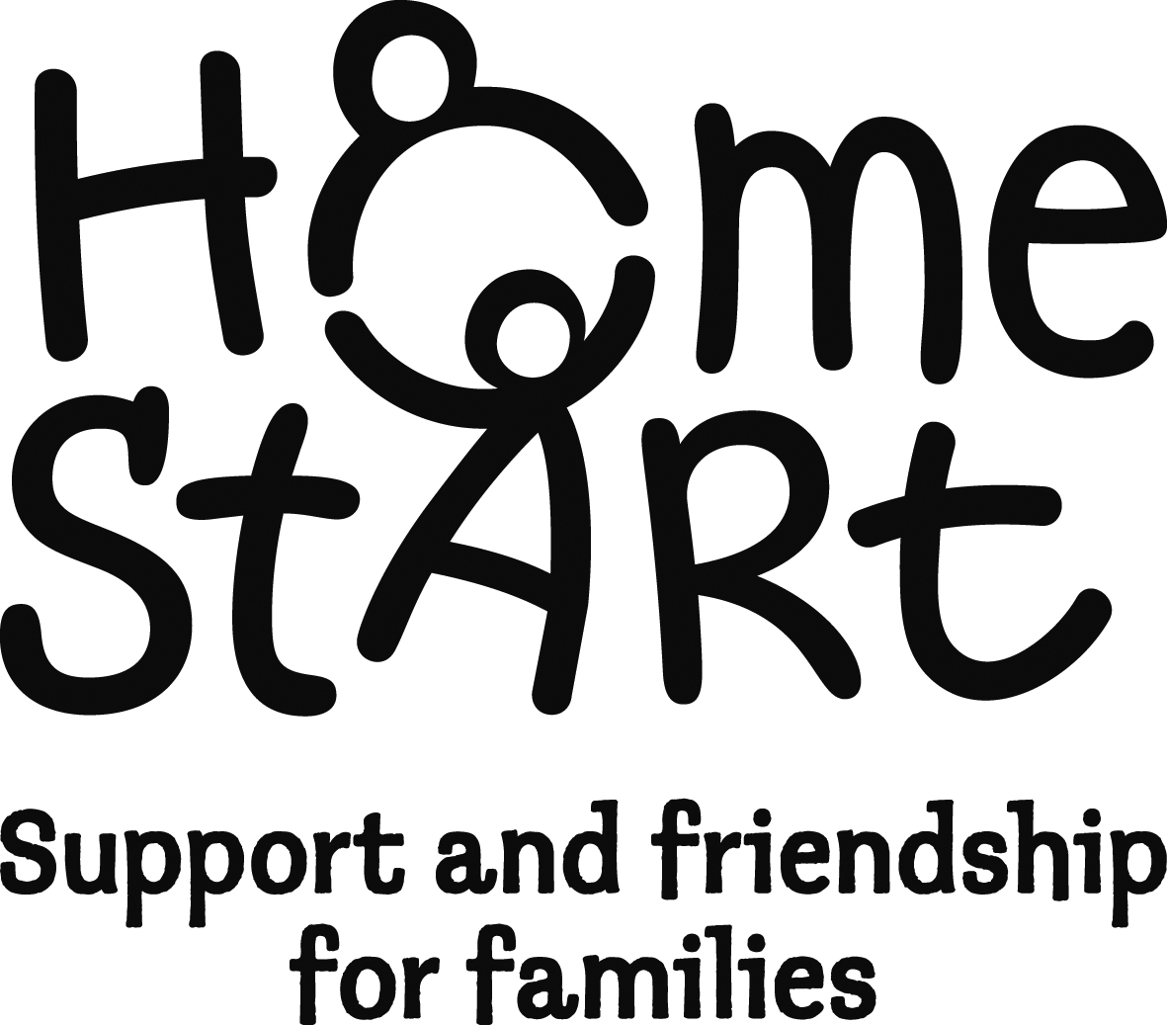
Home-Start South & West Devon Referral Form

Date referral received (scheme use):

Please note that all referrals must be made with the consent of the family.

Have you discussed this referral with the family prior to completing this form? YES / NO

The family must have at least one child under the age of twelve years.

Name of family……………………………………… Family No. (scheme use)…………………………..
Address……………………………………………………………………………………………………………
……………………………………………………………… Postcode ...………………………………………
Tel. No …………………………Mobile No …………………..………E mail ………………………………

Please provide some details about the adults caring for the child[ren]:
 | Name | Main carer √ | Resident in household√ | Comments
Mother/partner
Father/partner
Other main carer[s]
Other main carer[s]

Referred by: Date of referral:

Name  Role  Agency  Address  E mail  Postcode  Tel | Family Doctor  Tel  Health Visitor  Tel  E mail  Other agencies involved

Please √ all that apply to this family and give details:

Lone parent | substance abuse | domestic abuse | mental health issues | learning disabilities | post natal depression | Physical Disability | interpreter required | teenage pregnancy 19yrs or younger | other please specify

Have you visited the family home? YES / NO
Are there any Health and Safety issues that we need to consider when placing a volunteer with this family:

Please add any background information that you think we would find useful (if necessary attach an extra sheet):

Is this a referral for (please tick):

Home visiting | Group | Other

Details of children - Please note the family must have at least one child under the age of twelve years, (please include details of all children under 18)
Child’s name  (youngest first) | Gender |  | Date of birth | Immigration status |  |  | Considered to be disabled by main carer? √ if yes | Asian or Asian British |  |  |  | Black or Black British |  |  | Chinese or Other Ethnic Group |  | Mixed | White |  |  | Subject to assessment of needs e.g. CAF/ UNOCINI (√) | Who is the lead professional? | Child in need √ | Child care/ protection plan (√)
Child’s name  (youngest first) | Male | Female |  | Asylum seeker | Refugee | Pending | Considered to be disabled by main carer? √ if yes | Indian | Pakistani | Bangladeshi | Other Asian | Caribbean | African | Other | Chinese | Other Ethnic | Any mixed | British | Irish | Other White
C1.
C2.
C3.
C4.
C5.
C6.
C7.
C8
C9
C10.
Please complete those boxes which apply to any of the children

Note: the terms above are nation-specific - not all will be relevant in your area

Family needs - So that we can offer the family the most appropriate support, and match the most suitable volunteer, please complete the following table. Please note that there is not a ‘points’ system. Families will not be prioritised on the basis of how many categories are ticked. This information, together with information provided by the family, will be used to monitor how our support meets the family’s needs.

I hope that Home-Start will help meet needs the family has in the following areas:
Family needs | √ | If you have ticked, please tell us why this is a need
Managing child’s behaviour
Being involved in the child(ren)’s development
Coping with own physical health
Coping with own mental health
Coping with feeling isolated
Parent’s self-esteem
Coping with child’s physical health
Coping with child’s mental health
Managing the household budget
The day-to-day running of the house
Stress caused by conflict in the family
Coping with multiple birth/multiple children under 5
Use of services
Community Awareness
Details of other members of the household with responsibilities for caring for the children
 | Gender |  | Date of birth | Immigration status |  |  | Consider themselves to be disabled | Asian or Asian British |  |  |  | Black or Black British |  |  | Chinese or Other Ethnic Group |  | Mixed | White
 | Male | Female |  | Asylum seeker | Refugee | Pending | YES? | Indian | Pakistani | Bangladeshi | Other Asian | Caribbean | African | Other | Chinese | Other Ethnic | Any mixed | British | Irish | Other White
Main Carer
Partner living in household

Data Protection Act 1998: Family names and addresses are stored on our computer system, purely for internal administrative purposes and are only available to other parties following the express consent of the family concerned. Home-Start may share information with the original referrer unless specifically requested not to.

I have read and agreed with the above, and accept a visit from the Home-Start Co-ordinator. If you would like to know more about how we store your information, please refer to our privacy notice which is held on our website – www.homestart-southandwest.org.uk.

Referrer’s signature ………………………………… Date ………………. Parent’s signature ……………………………. Date ………………………

Thank you for taking time to provide this information which will help us to process the referral. We are unable to process your referral until we have received this form. We will try to respond to you within two weeks to tell you about progress with this referral. We will remain in touch while supporting this family and will contact you when the support ends. If you have any issues or concerns about the referral process or the support for the family please contact Andrea Chandler, Scheme Manager.

