Educational Psychology Service

**Emotionally Based School Avoidance – Guidance for Parents**

**Information for parents and carers to support children and young people experiencing Emotionally Based School Avoidance.**



**Plymouth Educational Psychology Service**

**What is Emotionally Based School Avoidance?**

Worrying or anxiety is a normal feeling that we all experience from time to time. It can even keep us safe from harm or help us perform in difficult situations. However, sometimes anxiety or excessive worrying can become a problem especially when it stops people doing what they want or need to do.

Many children and young people worry about school. This is normal. Anxieties are part of life and learning to deal with them is part of growing up. However sometimes a child’s worries may lead to difficulties attending school. If your child has high levels of anxiety and does not want to attend school they may be experiencing Emotionally Based School Avoidance (EBSA).

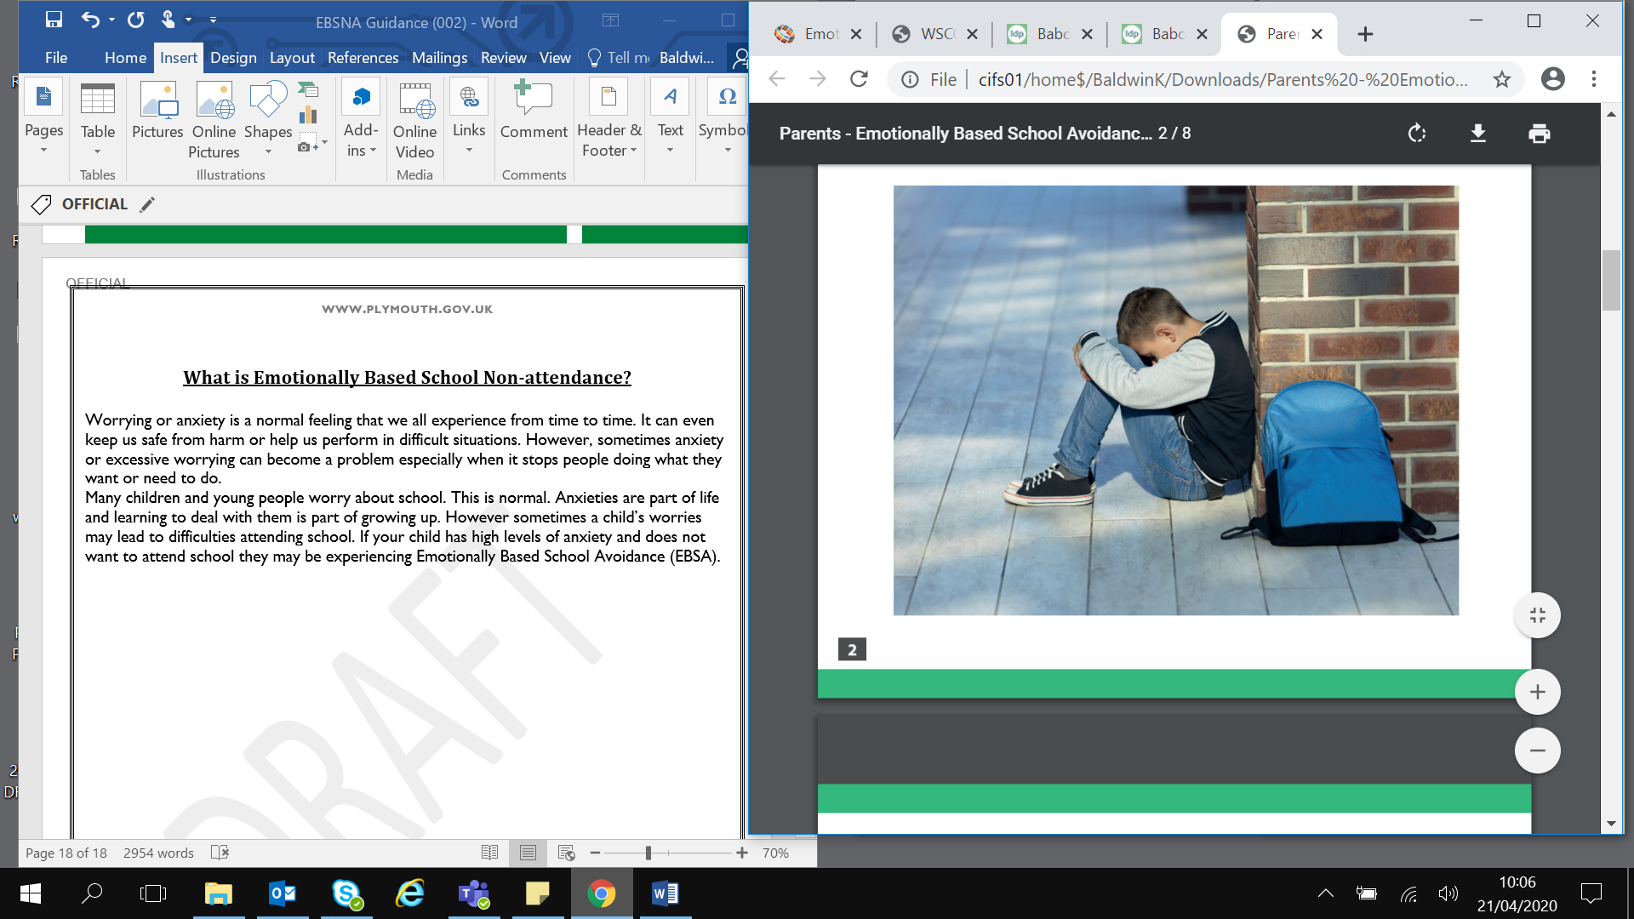

**Is your child worried about going to school?**

It is very important to try to help children and young people overcome these difficulties as soon as possible. Absences mean that children miss out on learning and friendships, making it even more difficult when they come back. The diagram below shows how EBSA behaviours can develop.

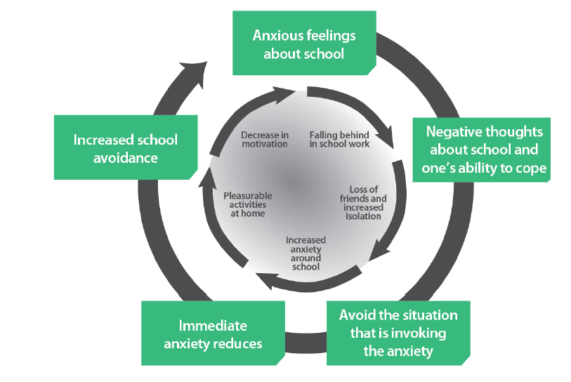

The longer the problems remain unaddressed the more difficult it becomes to change the school avoiding behaviour.

**Signs of EBSA**

These could include:

* Fearfulness, anxiety, tantrums or expression of negative feelings, when faced with the prospect of attending school.
* They may complain that they have abdominal pain, headache, sore throat, often with no signs of actual physical illness.
* Complain of anxiety symptoms that include a racing heart, shaking, sweating, difficulty breathing, butterflies in the tummy or nausea, pins and needles.
* The symptoms are typically worse on weekday mornings and absent at weekends and school holidays.

**What should you do?**

One of the most important ways you can support your child is to calmly listen to them and acknowledge that their fears are real to them. Remind them how important it is to attend school and reassure them that you and the school will work with them to make school a happier place for them.

Tell the school there is a problem as soon as possible and work in partnership with the school to address the issue. A plan should be made with the school to help your child. Towards the beginning of initiating the plan your child may show more unhappiness and you should prepare yourself for this.

It is really important that all adults both at home and school work together to agree a firm and consistent approach. Any concerns about the plan should not be shared with your child and a positive ‘united front’ is recommended.

It is likely that there may be difficulties implementing the plan and these should be anticipated and solutions found. You should try to keep an optimistic approach, if your child fails to attend school on one day, start again the next day. It is also important to remember there is likely to be more difficulty after a school holiday, period of illness or after the weekend.

You may feel tempted to change schools, however research tells us that often difficulties will re-emerge in the new school and whenever possible it is normally better to try to resolve the issue in the current school.

Finally, as a parent it can be really difficult to see your child unhappy. Make sure that you have someone to talk to too. This could be a friend, family member or an organisation such as those listed at the end of this leaflet.

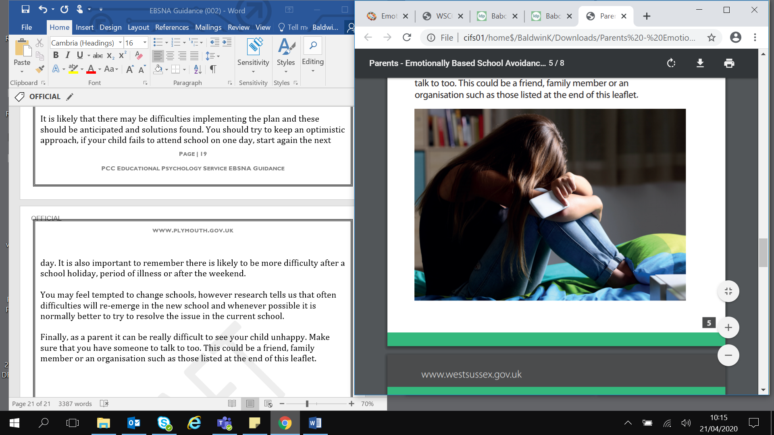

**What can you expect the school to do?**

* Listen carefully to you and your child. They should acknowledge the challenges faced by your child and you as their parent.
* Maintain close contact with you and your child, even during extended periods of non-attendance. An agreed member of staff should be named as a link person.
* Work in partnership with you and your child to find out what difficulties your child is experiencing and find ways of making school a happier place and improve their attendance.
* Co-ordinate planning meetings to create a team approach around your child (Team Around Me - TAM). This might include an early help assessment using an Early Help Advisory Tool (EHAT) to devise a plan in conjunction with you and your child. The plan should include what the next steps will be.
* Respond to any school-based needs, such as academic support, dealing with bullying or support with social relationships.
* Consider the support your child might require upon arrival at school. This might include meeting with a friend at a specific place and time, using a quiet space to settle before school starts, engaging in a preferred activity or being given a responsibility such as a monitor role.
* If difficulties persist the school should consider requesting involvement from other professionals starting with their link Educational Psychologist.
* The school should refer to the Plymouth Educational Psychology Service EBSA Guidance Document.

**Talking to your child about their worries**

Any child currently avoiding school is likely to become anxious when they are asked to talk about their difficulties or returning to school. A good place to start is to acknowledge that it may be difficult but that you would like to know what they think and feel. If they find it difficult to talk, you could ask them a specific question this might help them start to sort through their fears and feelings. For example:

* What three things are you most worried about?

Or

* What three things were you recently worried about?

It is also important to focus on positives:

* What are the three best things about school?

Sometimes children may find it hard to tell you face to face, perhaps you could ask them to write it down, email or text you. Some children also find it easier to draw how they are feeling.

We have also produced information booklets for children and young people. These have some ideas for activities children and young people can do. Your child’s school should be able to give you a copy.

**Supporting young children**

It is common for young children to get worried or anxious about all kinds of things. It is part of development and learning about the world. For example, toddlers may be scared of loud noises whereas 4-5 year olds are often afraid of monsters or the dark. This is normal and it is likely that your child will simply outgrow these fears. It is normal for young children to feel anxious when saying goodbye to their parents and separation anxiety is a normal stage of child development. If your child’s high levels of anxiety persist and they do not want to attend school they may be experiencing EBSA.

Talking to young children about worries may be difficult but it is important to acknowledge their worries and respect them. There may be a number of reasons why a young child may experience EBSA, these include fearfulness of school, mental health needs, attachment related difficulties or learning difficulties (British Psychological Society, 2017).

One of the most important ways you can support your child is to calmly listen to them and acknowledge that their fears are real to them. Remind them how important it is to attend school and reassure them that you and the school will work with them to make school a happier place for them

**What could you do?**

Below are a number of strategies you could use with your young child. Think about which would be most appropriate to your individual situation. Everyone experiences things differently and it is important to consider the individual needs of your child and your situation.

Think about ways that your child can learn what they need to learn through doing. What can your child have a go at, what opportunities need to be created and how can we encourage your child to have a go to make new discoveries that enable them to overcome any anxieties (Creswell and Willetts, 2019). This may include a step by step plan. Encourage your child to devise the step by step plan with you, identify an ultimate goal and work out a series of gradual steps to build up to this goal. Think of ways in which you can motivate your child to have a go at each step. Make sure your child understands they will get rewards if they can have a go at each step. Be clear about what they are getting rewards for. Praise your child every time they attempt a step, not just the once. Continue to give rewards if your child still feels fearful about trying the next step. Give any rewards immediately or as soon as possible when your child has completed the step. With younger children rewards/motivators that involve doing things with you can be as meaningful as material rewards. Give your child lots of praise for completing steps. Any rewards or activities suggested as part of the step by step plan should be considered additional and on top of what a family would be doing together. The step by step plan should not encourage you to withhold happy family occasions from children who are experiencing EBSA.

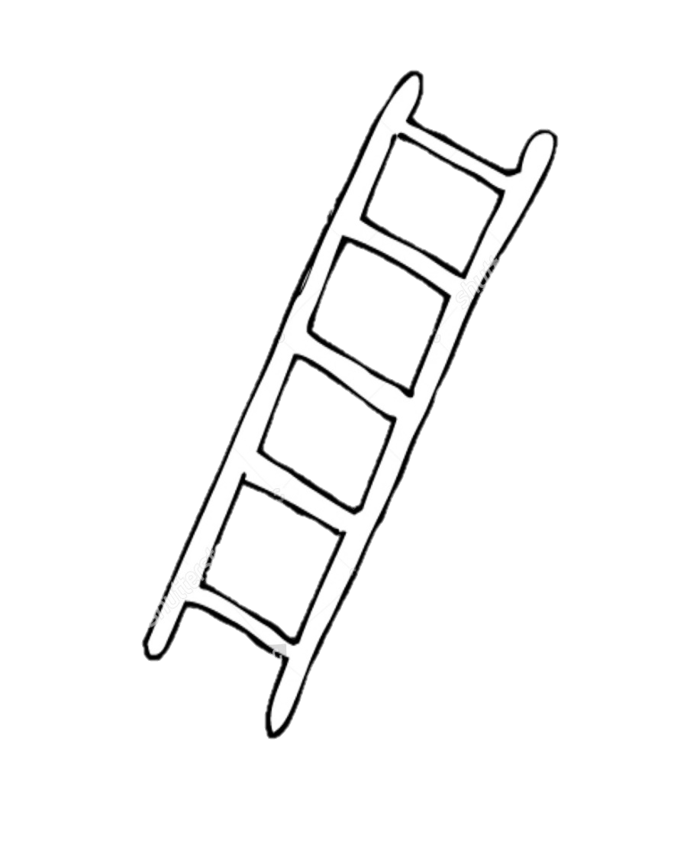

**Steps:**

Going to school and staying in school for the morning

Meeting Miss Smith and going to school for break and lunch time

Walking my sister to school with Mummy

Getting dressed for school

**Rewards/Doing things together**:

A family day trip to the beach

Choosing a film to watch

Going to the park on the way home

Playing with my special cars after breakfast

*An example of a step by step plan where the ultimate goal is for the child to attend school for the whole morning.*

Try practical strategies that help the child be in control of their anxiety, such as a ‘worry box’. Designate a ‘worry time’ for each day, write it down, post it in to the box, close the lid and don’t give any more time to worry about the anxiety that day.

Workbooks such as Starving the Anxiety Gremlin by Kate Collins-Donnelly (2013) may be a helpful way for a young child to understand what anxiety is and work through how to get their anxiety under control.

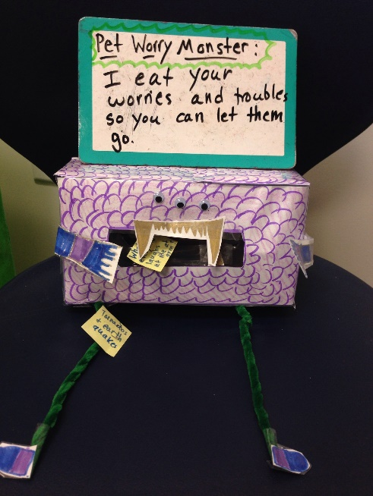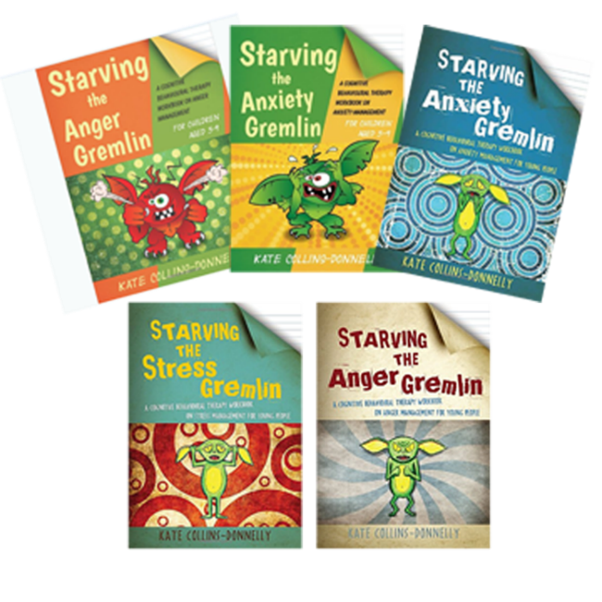

*An example of a worry box and Kate Collins-Donnelly’s workbooks*

Encourage your child to become a thought detective. You can do this by teaching them the 3Cs method below:

***Catch your thoughts.*** Imagine every thought you have floats above your head in a bubble. Try and catch one of the worried thoughts and think about this (e.g. “I don’t have any friends in school”); it can help to write it down.

***Collect evidence.*** Next, collect evidence to support or negate this thought. (Supporting evidence: “I had a hard time finding someone to sit with at lunch yesterday.” Negating evidence: “Sophie and I do homework together and she’s a friend of mine.”)

***Challenge your thoughts.*** Think about the evidence you have collected and decide whether, based on the facts, the worry is true (e.g. “No, it’s not true, Sophie is my friend at school”).

**Supporting older children and young people**

Teenagers may be particularly likely to be sensitive to what they think other people are thinking about them and may also be sensitive to feeling that parents and carers are interfering in their lives as they strive for independence. One of the most important ways you can support your young person is to calmly listen to them and acknowledge that their fears are real to them.

There may be a number of reasons why a young person may experience EBSA, these include fearfulness of school, mental health needs, attachment related difficulties or learning difficulties.

Any young person currently avoiding school is likely to become anxious when they are asked to talk about their difficulties or returning to school. A good place to start is to acknowledge that it may be difficult but that you would like to know what they think and feel.

If they find it difficult to talk, you could ask them a specific question this might help them start to sort through their fears and feelings. For example:

* What three things are you most worried about?
* Or. What three things were you recently worried about?

It is also important to focus on positives:

* What are the three best things about school?

Sometimes young people may find it hard to tell you face to face, perhaps you could ask them to write it down, email or text you. Some young people also find it easier to draw how they are feeling.

Young people may benefit from being put in a position to have greater control over the strategies that they use to overcome their EBSA. Although they will still need your support and guidance they will be more capable of carrying out some of the strategies independently and are likely to want to do them independently.

**What could you do?**

Below are a number of strategies you could use with your young person. Think about which would be most appropriate to your individual situation. Everyone experiences things differently and it is important to consider the individual needs of your young person and your situation.

Kearney and Silverman (1990) suggest that choice of intervention should be governed by a careful functional analysis of school avoidance behaviour. They describe four types of variable which can maintain school avoidance behaviour, however several of these may be involved and their effects will be interactive. Interventions should be bespoke to the individual and based upon the information which was gathered in the assessment and integration stage.

You may be able to create a support plan alongside your young people, this can be flexible and all actions should be agreed with the young person. For example:

|  |  |  |  |
| --- | --- | --- | --- |
| **Support Plan** | | | |
| Name: | | Date agreed: | |
| *At school these things can make me upset/things I find difficult:* | | | |
| *My key adults in school is/are:*  When I can speak to my key adult(s):  Where I can speak to my key adult(s): | | | |
| *Until ________ my return to school plan includes the following changes to my attendance:*  (Identify any change to days or times attending school) | | | |
| *Changes to my timetable include:*  (Identify any changes needed and what should happen/where they are expected instead) | | | |
| *Any other changes include:*  Identify any other changes to routines (break, lunchtimes, changes between lessons etc.) classroom expectations (not expected to read aloud, work in pairs etc.) or homework | | | |
| *When I start to get upset, I notice these things about myself:* | | | |
| *When I start to get upset, others notice these things about me:* | | | |
| *Things I can do to make myself feel better when I’m in school are:* | | | |
| *Things that other people (staff and friends) can do to help me feel better when I’m at school:* | | | |
| *Things that my family can do to support me to attend school:* | | | |
| *Places where I can go to in school where I feel safe and supported:* | | | |
| This plan will be reviewed regularly so that it remains helpful.  *Review date:* | | | |
| *My signature* | *Key adults in schools signature* | | *Parent signature* |
| *Other people who have access to the plan are:* | | | |

Familiar school staff could discuss with young people and their parents what they are looking forward to and what they are worried about and this should be individually addressed. An example of support for this are ‘What if cards…’

|  |  |  |
| --- | --- | --- |
| **What if I don’t know where my classroom is…** | **What if someone calls me an unkind name…** | **What if I have nothing to do at break time…** |
| I will get my timetable from my school planner and see if I can work it out | I will try and walk away and not swear or shout | I could to the library |
| I will try and ask someone in my class | I will tell a teacher why I feel upset | I could buy a snack and eat it in the dining hall |
| I will ask my teacher | My teacher will deal with it and talk to that person | I could find my buddy |

We have also produced information booklets for children and young people. These have some ideas for activities children and young people can do. Your child’s school should be able to give you a copy.

**Further sources of support**

Information regarding local services and organisations can be found on the Plymouth Local Offer.

<https://www.plymouthonlinedirectory.com/plymouthlocaloffer>

**Educational Psychology Service**

Educational Psychologists use psychology to support the educational progress, development, mental health and wellbeing of children and young people from 0-25 years with complex special educational needs and, or a disability.

More information can be found on the Plymouth Educational Psychology Service Local Offer page <https://www.plymouthonlinedirectory.com/plymouthlocaloffer/educationalpsychologyservice>

We may provide support around EBSA in relation to:

* We support families, early years settings, schools and colleges. Our role usually involves **joint working** with a range of other professionals as part of a Team Around the Child or Child.
* The service also supports a wide range of needs by providing **training**, **consultation** and project work for adults, such as carers, teachers and early years practitioners, who work with children and young people.
* We conduct research and evaluation projects in order to achieve high-quality provision for children and young people.
* Educational Psychologists provide **consultation**, **assessment** and **advice** on strategies to promote positive outcomes.
* We undertake psychological assessment for all children and young people with special educational needs who require a statutory Education Health and Care Plan.

Contact details:

01752 224962

[psychology.service@plymouth.gov.uk](mailto:psychology.service@plymouth.gov.uk)



**CAMHS Community Duty Line**

This phone line is for all young people, parents and professionals in Plymouth who are open to CAMHs or not seeking advice, signposting, or emotional support. Self-referral can be considered with a professional utilising this phone line

Contact details:

01752 431613

Phone line Mon-Fri 12pm-5pm excluding bank holidays



**Plymouth Information, Advice and Support for SEND (PIAS)**

Contact details:

01752 258933 / 0800 953 1131

pias@plymouth.gov.uk

PIAS provides information, advice and support relating to Special Educational Needs and Disabilities (SEND) for parents, carers, children and young people within the Plymouth Local Authority area. PIAS work 1:1 with parents and carers with support at meetings and with education and training issues.



**Inclusion, Attendance and welfare services.**

The Inclusion, Attendance and Welfare Service consists of a team of skilled professionals, including Educational Welfare Officers, experienced in dealing with the most vulnerable children and children in Plymouth.

The team provides advice to schools around EBSA in relation to:

* Child protection and safeguarding
* Attendance and behaviour
* Legal responsibilities
* Children Missing Education

In addition it:

* Supports parents and schools to ensure children access their entitlement to an efficient and suitable education
* Identifies and shares good practice in schools, signposts and supports referrals to appropriate intervention
* Monitors attendance data
* Provides advice, guidance and training

Contact details:

01752 307405

[IAWS@plymouth.gov.uk](mailto:IAWS@plymouth.gov.uk)



**Livewell Southwest School Nursing Team**

School nursing team works with children, their parents and professionals to ensure young people’s health needs are met and supported – at home, at school and in the wider community. The experienced registered nurses and health workers offer confidential advice and support on a range of physical and emotional health issues.

Contact details PHN Hub:

01752 434008

Livewell.phnadminhub@nhs.net



**Young minds**

A charity championing the wellbeing and mental health of young people. They publish a range of information for parents.

They also have a parent helpline.

Calls are free Mon-Fri from 9:30am to 4pm 0808 802 5544

Website: <https://youngminds.org.uk/find-help/for-parents/>

**Not Fine in Schools**

Not Fine in School is a parent-led organisation supporting families experiencing school refusal & attendance difficulties & raising awareness of related issues.

<https://notfineinschool.org.uk/>