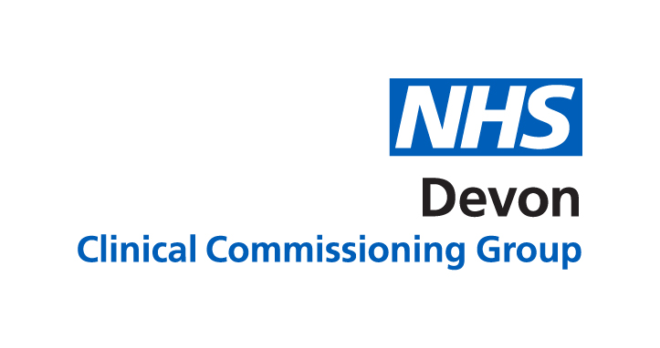

**Designated Medical Officer and Designated Clinical Officer**

The Designated Medical Officer and Designated Clinical Officer work on behalf of the CCG/ICS and have key roles to support joined-up working between the health services and local authorities to implement the Children’s Act Reforms.

We endeavour to work as a virtual team with all officers being able to offer advice and support across the Plymouth/Devon Footprint.

This is in line with the local SEND strategy.

Our role is primarily to ensure a positive Education Health Care Plans process from a health perspective and explore options around Early help and support for young people with SEND.

Therefore, we work with healthcare providers to ensure they are part of the integrated planning process and ultimately to help enable the best outcome for children and young people through the SEND process.

Brigitte Price is the designated clinical officer Plymouth facing and Jane Dunlop is the Designated Medical within a bigger team of health officers.